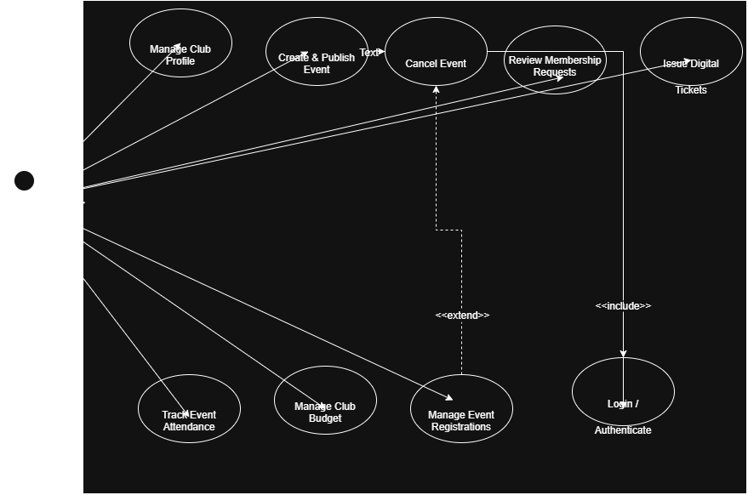
3.2.2 Use Case Descriptions

1. Manage Profile
- Primary Actor: Club Manager
- Pre-conditions: Manager is logged into the system.
- Main Flow:
  - Manager selects "Manage Profile".
  - System displays current club details (description, logo, contact info).
  - Manager edits the information and clicks "Save".
  - System validates and updates the profile data.
- Post-conditions: Profile details are successfully updated in the system.
2. Create/Publish Event
- Primary Actor: Club Manager
- Pre-conditions: Manager is authenticated and has active club privileges.
- Main Flow:
  - Manager selects "Create Event".
  - System displays the event creation form.
  - Manager fills in details (title, date, location, ticketing rules) and submits.
  - System validates the input and publishes the event to the platform.
- Post-conditions: Event becomes visible to students for registration.
3. Manage Event Registrations
- Primary Actor: Club Manager
- Pre-conditions: Event has been created and registrations exist.
- Main Flow:
  - Manager opens "Manage Registrations" for a specific event.
  - System retrieves and displays the list of registered attendees.
  - Manager views, exports, or modifies registration statuses.
- Post-conditions: Attendee list is reviewed and updated.
4. Issue Digital Tickets
- Primary Actor: Club Manager
- Pre-conditions: Student registration is confirmed.
- Main Flow:
  - Manager triggers ticket issuance for confirmed attendees.
  - System generates unique digital tickets (QR codes).
  - System dispatches tickets to registered attendees.
- Post-conditions: Digital tickets are delivered to users.
5. Track Event Attendance
- Primary Actor: Club Manager
- Pre-conditions: Event is currently active or concluded.
- Main Flow:
  - Manager accesses "Track Attendance".
  - System provides scanner interface / manual check-in options.
  - Manager validates attendee tickets upon entry.
  - System updates check-in status in real time.
- Post-conditions: Final attendance count and logs are stored.
6. Manage Club Budget
- Primary Actor: Club Manager
- Pre-conditions: Manager holds authorized financial access.
- Main Flow:
  - Manager navigates to "Manage Budget".
  - System displays current allocation, expenses, and balance.
  - Manager logs new expenses/income or requests budget approvals.
  - System recalculates and updates the financial balance.
- Post-conditions: Financial records are recorded and balanced.
7. Review Membership Requests
- Primary Actor: Club Manager
- Pre-conditions: Students have submitted join requests.
- Main Flow:
  - Manager selects "Review Membership Requests".
  - System displays pending applicant profiles.
  - Manager accepts or rejects individual requests.
  - System notifies applicants of the decision.
- Post-conditions: Approved applicants are added to the official club membership roster.

